**Spring Data JPA**

Spring Data JPA is part of Spring Data family. Spring Data makes it easier to create Spring driven applications that use new ways to access data, such as non-relational databases, map-reduction frameworks, cloud services, as well as well-advanced relational database support. This article will discuss about Spring Data JPA. We will also look into Spring Data JPA example application.

**Features** :

Some of the features provided by Spring Data JPA are:

1. Sophisticated support to build repositories based on Spring and JPA
2. Support for [Querydsl](http://www.querydsl.com) predicates and thus type-safe JPA queries
3. Transparent auditing of domain class
4. Pagination support, dynamic query execution, ability to integrate custom data access code
5. Validation of @Query annotated queries at bootstrap time
6. Support for XML based entity mapping
7. JavaConfig based repository configuration by introducing @EnableJpaRepositories.

**When to use Spring Data JPA?**

I would say that if you need to quickly create a JPA-based repository layer that is mainly for CRUD operations, and you do not want to create abstract [DAO](https://www.journaldev.com/16813/dao-design-pattern), implementing [interfaces](https://www.journaldev.com/1601/interface-in-java), Spring Data JPA is a good choice.

**CrudRepository methods :**

* save
* findOne
* exists
* findAll
* count
* delete
* deleteAll

**Why is it useful?**

Implementing a data access layer of an application has been cumbersome for quite a while. Too much boilerplate code has to be written to execute simple queries as well as perform pagination, and auditing. Spring Data JPA aims to significantly improve the implementation of data access layers by reducing the effort to the amount that’s actually needed. As a developer you write your repository interfaces, including custom finder methods, and Spring will provide the implementation automatically.

The repositories present within the Spring Data Commons and Spring Data JPA Project :

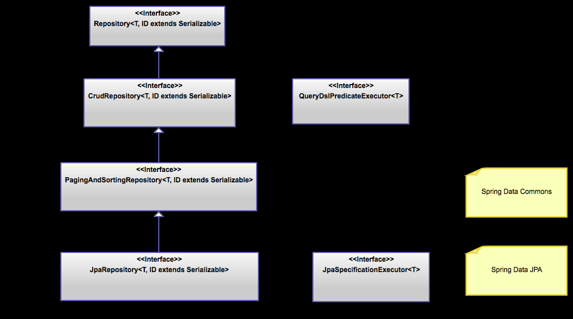

References :

<https://docs.spring.io/spring-data/jpa/docs/current/reference/html/#repositories.core-concepts>

<http://projects.spring.io/spring-data/>

<https://projects.spring.io/spring-data-jpa/>

<https://github.com/spring-projects/spring-data-examples/tree/master/jpa>